|  |  |  |  |  |
| --- | --- | --- | --- | --- |
| |  |  | | --- | --- | | Furniture Project |  | |  |  | |
| John Durand  05/13/21 |

Table of Contents Introduction........................................................... 2

Vision Statment.................................................................................................. 4

Project Overview...................................................................................... 5

Project Overview cont.- ................................................................................................. 6

Project Overview cont.-.......................................................................... 7

Project Overview cont.-.............................................................................................. 8

Functional requirements and nonfunctional requirements ................................................................................................................ 9

Workflow Diagram ....................................................................................................... 10

Workflow Diagram cont.- ................................................................ 12

User Case................................................................................. 13

Entry Relationship Diagram ........................................................................ 14

System Sequence Diagram ...................................................... 15

Viper Module Description ..................................................................... 16

Viper Module Diagram .................................................... 17

Unified Modeling Language Diagram ......................................................................... 18

User Interfaces..................................................... 19

Database .................................................................................. 20

Data Deployment Diagram .......................................................... 21

Reference Page ............................................................ 22

**Project management - an overview**

**FURNITURE PROJECT**

**Vision Statement - To Create a more interactive furniture shopping experience for customer while offering world class service.**

**Mission Statement - Our mission is to create an easier way to purchase furniture online with a more flexible and reliable way to get them. Our customer is offered the best experience and the most comfortable services.**

**Project overview document**

**[Furniture Project - see below]**

**[2/14/21]**

**Furniture Project**

This application showcases all the furniture products for shopping, making the customer a comfortable online shopping experience with a real look and feel of the furniture.

**Project overview statement**

To buy products, the customer has to have an account. Those who do not have an account can only view the available product. Once the customer authenticates his credentials, not only he can view the products, but he can also place an order to buy those products. This application then generates a bill for that particular customer. After the confirmation, the customer has to enter his payment option to buy those products.

**Introduction / Background to project**

Compared to other online shopping their system doesn’t allow all types of payment and has a small number of products available. My system has a wide range of varieties of products available in the market. Easy payment through all the credit and debit cards. Cash on delivery and internet banking is also available.

**Business case**

A furniture app is easy to promote and will help improve customer reach. While generating faster, easier orders and sales

**Deliverables**

The software will store data for future purchases.

The app will be linked to 3rd party furniture manufacture

My app will provide faster and easier ways to get furniture shipped to your home straight from the manufacture.

My app will allow individuals to create an account, easily browse through furniture, check out, and complete purchase.

**Constraints**

The project has to be completed by 5/13/21

The delivery should take no less than a month if coming from oversea

There is no required budget for completion

The project is an induvial assignment

**Key people / Key stakeholders**

**Project lead** or **project manager**

[John Durand, 9084469956]

Creating whole info structure, software and guidelines.

**Client** - or named contact in the area of the business the project is being carried out for

[Felician University, 2015596000]

**project administration**

[Dr. Sofya Poger, PogerS@felician.edu]

Making sure the information is correct and all the details of the project is included

**In scope**

My app will have multiple product choice

A simple design

Great User Interface design

Easy price and comparison

No crowds, just save and purchase

Good Security

**Out of scope**

This project won’t cover

3D models when shopping online

Furniture Quality

Storage

long shipment time

**Functional requirements of furniture project-**

* Descriptions of data to be entered into the system
* Descriptions of operations performed by each screen
* Descriptions of workflows performed by the system
* Descriptions of system reports or other outputs
* Who can enter the data into the system?
* How the system meets applicable regulatory requirements

### Non-Functional requirements of furniture project-

Capacity- the maximum amount that something can contain

Security - What are the security requirements, both for the physical installation and from a cyber perspective?

Usability- This focuses on the appearance of the user interface and how people interact with it. What color are the screens? How big are the buttons?

Maintainability- is defined as the probability of performing a successful repair action within a given time.

Serviceability- the quality of being able to provide good service. serviceableness, usability, useableness, useableness. usefulness, utility - the quality of being of practical use.

Reliability- the degree to which the result of a measurement, calculation, or specification can be depended on to be accurate.

Performance- How fast does it need to operate?

**Work Flow / Activate Diagram**

USER CASE

Furniture Project



I<<nclude >>

Customer

I<<nclude >>

I<<nclude >>

I<<nclude >>

I<<nclude >>

I<<nclude >>

Developer



**Entry Relationship & System sequence Diagram**

Architecture and Software

**Viper Module**

“A Viper is an iOS architecture that divides a feature implementation into 5 distinct layers in one module, Viper is only accessible on XCode.”

* **V: View**

displays what it is told to by the Presenter and relays user input back to the Presenter. The Presenter only knows about the content it maintains and when it should be displayed. It is up to the View to determine how the content is displayed.

* **I: Interactor**

contains the business logic as specified by a use case it manipulate model objects to carry out a specific task.

* **P: Presenter**

contains view logic for preparing content for display (as received from the Interactor) and for reacting to user inputs (by requesting new data from the Interactor). It gathers input from user interactions so it can update the UI and send requests to an Interactor

* **E: Entity**

contains basic model objects used and only manipulated by the interactor.

* **R: Router**

contains navigation logic for describing which screens are shown in which order. Routes from one screen to another are defined in the wireframes created by an interaction designer

Manipulate data and use cases

Owns & ask for updates

Updates

**Interactor**

**View**

**Presenter**

Notifies

Owns & send user action

Knows about

**Router**

System Interfaces

**Unified Modeling Language Diagram**

User Interfaces

Database

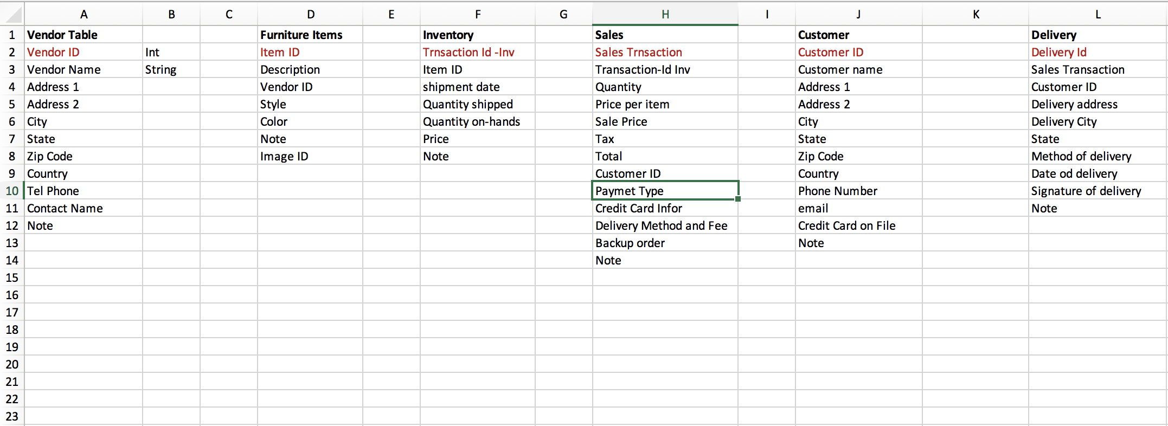

Data Deployment Diagram

**Glossary**

**Functional requirement**- defines the basic system behavior it’s what the system does or must not do.

**Non-functional requirement**- shows specify how the system should complete an induvial task

**Workflow Diagram**- A workflow diagram is a visual representation of a business process usually done through a flowchart. It uses standardized symbols to describe the exact steps needed to complete a process, as well as pointing out individuals responsible for each step.

**Activity diagram-** Activity Diagrams describe how activities are coordinated to provide a service which can be at different levels of abstraction. Typically, an event needs to be achieved by some operations, particularly where the operation is intended to achieve a number of different things that require coordination, or how the events in a single use case relate to one another, in particular, use cases where activities may overlap and require coordination.

**User Case**- A use case diagram is a graphical depiction of a user's possible interactions with a system. A use case diagram shows various use cases and different types of users the system has

**Entry Relationship Diagram**- An entity relationship diagram (ERD) shows the relationships of entity sets stored in a database. An entity in this context is an object, a component of data. An entity set is a collection of similar entities. These entities can have attributes that define its properties.

**System Sequence diagram**- A **sequence diagram** shows object interactions arranged in time sequence. It depicts the objects involved in the scenario and the sequence of messages exchanged between the objects needed to carry out the functionality of the scenario.

**Viper module**- Viper is an architecture that divides a feature implementation into five distinct layers in one module. Each character of *VIPER* represents a different layer. It’s an iOS architecture that is used on XCode.

**Unified Modeling Language Diagram**- UML, short for Unified Modeling Language, is a standardized modeling language consisting of an integrated set of diagrams, developed to help system and software developers for specifying, visualizing, constructing, and documenting the artifacts of software systems, as well as for business modeling and other non-software systems.

**user interface**- (UI) is anything a user may interact with to use a digital product or service. This includes everything from screens and touchscreens, keyboards, sounds, and even lights. To understand the evolution of UI, however, it’s helpful to learn a bit more about its history and how it has evolved into best practices and a profession.

**Data Deployment Diagram**- In the UML, deployment diagrams are used to visualize the static aspect of these physical nodes and their relationships and to specify their details for construction.

Reference page

Ian Sommerville “Engineering Software Products”, Pearson, ISBN-13: 978-0-13-

521064-2

Ian Sommerville “Software Engineering”, Tenth Edition, Pearson, ISBN-13: 978-

0-13-394303-0Stephen R. Schach “Object-Oriented and Classical Software

Engineering”, Eighth Edition, McGraw Hill, ISBN: 978-0-07337618-9

<https://www.template.net/business/project-templates/project-overview/> 7+ Project Overview Templates template.net all rights reserved © 2021

<https://tallyfy.com/workflow-diagram/> What is a workflow Diagram? © 2014 - 2021 Tallyfy, Inc

<https://www.uml-diagrams.org/use-case-diagrams.html> UML Diagram Copyright © 2009-2020 uml-diagrams.org.

<https://www.smartdraw.com/entity-relationship-diagram/> Entity Relationship Diagram ©1994-2021 [SmartDraw, LLC](https://www.smartdraw.com/about/" \t "_blank)

<https://www.visual-paradigm.com/guide/uml-unified-modeling-language/what-is-sequence-diagram/> What is a sequence diagram? @2020 by Visual Paradigm. All rights reserved.

<https://medium.com/trendyol-tech/creating-an-ios-viper-module-step-by-step-guide-cd1f414b7dd3> Creating an iOS Viper Module- Step by Step Guide ,Emre Ergün, May 28,18

<https://www.raywenderlich.com/8440907-getting-started-with-the-viper-architecture-pattern> Getting started with the Viper Architecture Pattern by Michael Katz Apr. 20 ,2020

<https://tallyfy.com/uml-diagram/> All You Need to Know About UML Diagrams: Types and 5+ Examples © 2014 - 2021 Tallyfy, Inc. All rights reserved

<https://searchapparchitecture.techtarget.com/definition/user-interface-UI> User Interface (UI) by Fred Churchville All Rights Reserved, [Copyright 2019 - 2021](https://searchapparchitecture.techtarget.com/about/copyright), TechTarget

<https://www.visual-paradigm.com/guide/uml-unified-modeling-language/what-is-deployment-diagram/> What is deployment diagram? @2020 by Visual Paradigm. All rights reserved.

<https://qracorp.com/functional-vs-non-functional-requirements/>

Functional vs Non-Functional Requirements: The Definitive Guide Copyright 2020

<https://www.visual-paradigm.com/guide/uml-unified-modeling-language/what-is-activity-diagram/>

What is a activity diagram? @2020 by Visual Paradigm. All rights reserved.